AIRLINE RESERVATION SYSTEM

C HAREESH

(192110282)

3) Make an Online Airline Reservation System. The activities of the Online Airline Reservation system are listed below user, admin, LOGIN, MANANGE CLASSES, MANANGE WAITING LIST, MANAGE HOLDS, MANAGE DEADLINES, LOGOUT, using this has a step-by-step process draw a CLASS diagram.

**AIM:**

To develop a **UML Class Diagram** for an **Online Airline Reservation System**, which models the interactions between users, admins, and various reservation management functionalities.

PROCEDURE:

1. **Identify Key Classes:**
   * **User**: Represents passengers booking flights.
   * **Admin**: Manages the system.
   * **Flight**: Contains details about flights.
   * **Reservation**: Manages bookings.
   * **Waiting List**: Handles passengers on standby.
   * **Hold**: Manages temporary reservations.
   * **Deadline**: Sets time limits for reservations.
2. **Define Attributes and Methods:**
   * **User**: user-ID, name, email, login (), logout (), make Reservation ()
   * **Admin**: admin ID, manage Classes (), manage Waiting List (), manage Holds (), manage Deadlines ()
   * **Flight**: flightID, origin, destination, departureTime, availability
   * **Reservation**: reservation ID, user-ID, flight ID, status, confirm Booking (), cancel Booking ()
   * **Waiting List**: add-To-Waiting List(), remove From Waiting List()
   * **Hold**: place Hold(), release Hold()
   * **Deadline**: set-Deadline(), check Deadline()
3. **Establish Relationships:**
   * A **User** can make multiple **Reservations**.
   * A **Reservation** is linked to a **Flight**.
   * The **Admin** manages **Classes**, **Waiting List**, **Holds**, and **Deadlines**.

**Output:**

**CLASS DIAGRAM:**

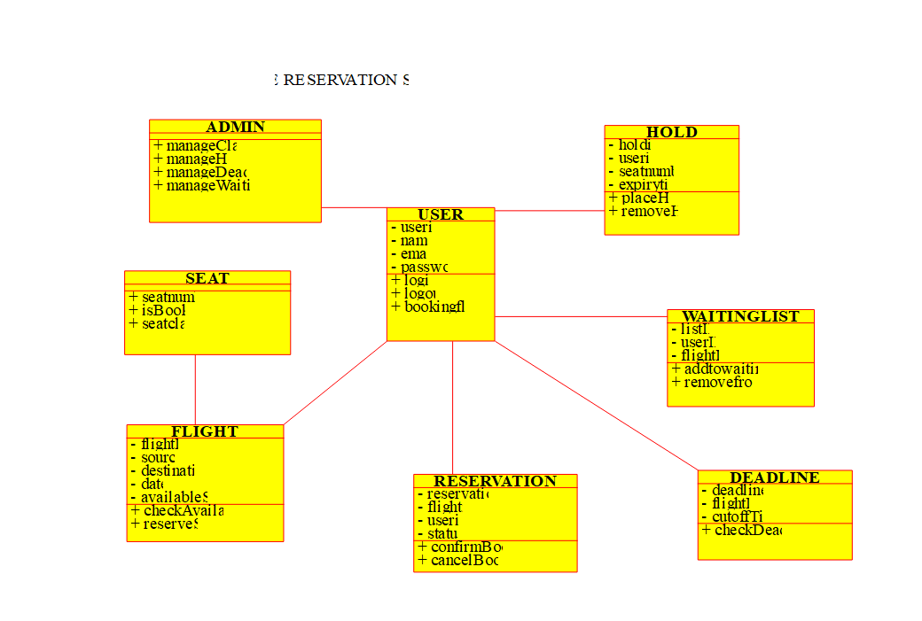

**RESULT:**

**UML Class Diagram** is successfully get designed.